**Name**: Implications of Multiple Disabilities

**Description**:

This section will shed light on the effects of multiple disabilities on the life and learning ability of individuals affected.

**IMPLICATIONS OF MULTIPLE DISABILITIES FOR EDUCATION**

The effect of multiple disabilities depends on individual conditions such as the number and nature of disabilities a person has, and the promptness and comprehensiveness of the rehabilitation provided. We shall further discuss the implications depending on the nature component disabilities.

**Disabled Physical-Motor Functioning**

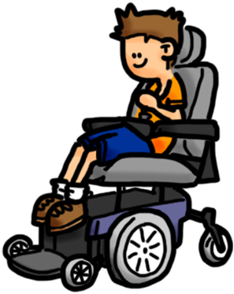

*Figure 1:* Physical-motor conditions.

If multiple disabilities is a plurihandicap involving physical-motor components, then physical wellbeing and motor functioning may be affected in the individuals. Their physical growth and development may be delayed, deficient or deviant. The sensory-motor functions may be impaired. These in turn have a wide range of consequences such as – the individual might have limited attention and concentration and may become easily tired when carrying out physical work. As a result they may need to spend more time and effort to complete tasks, which will further add to their weariness. Depending on organs or limbs affected they may have difficulty in hand functioning, mobility or both. These in turn may affect persons’ ability to take care of themselves and function independently. With relevance to education, these fundamental problems may consequently affect their access to the learning environment and facilities. Their ability to handle learning tools might be restricted and this in turn may limit their participation in the learning activities and diminish performance and learning outcomes.

**Deficient Learning Ability and Study Skills**



*Figure 2:* Learning abilities and study skills.

If multiple disabilities involve intellectual components, teething troubles may occur in the form of perceptual-cognitive difficulties, that is, difficulty in recognising and comprehending the information received through their different senses. If combined with physical restrictions to mobility and handling of learning material and tools, they might severely constrain general exposure and learning experience of individuals. In the educational context, presence of intellectual disabilities may limit the general ability for understanding and also slow down the ability to learn resulting in need for more time and repeated efforts for thorough learning. Affected individuals may also have difficulty in remembering what they have learnt. Consequently they might not perform adequately in tests and examinations and will have limitations in demonstrating the knowledge and skills that they have learnt. Further they might be unable to generalise and apply their learning outside classroom context and solve new problems. Generally children with multiple disabilities including intellectual deficiencies are found to lack in organised study habits and skills.

**Impaired Ability for Communication**



*Figure 3:* Alternate communication modes.

If any of the communication disorders such as autism spectrum disorder, cerebral palsy, hearing impairment, intellectual disability, learning disability, etc. is present among the multiple disabilities, they may impair the ability to use verbal or spoken language for communication and sometimes lead to difficulty in reading and writing skills. The affected persons may have difficulty in attending to and comprehending what others communicate and clarify what they do not understand. They may also have difficulty in responding spontaneously, meaningfully and fluently. All told, their efforts to communicate may turn to be tiring and time consuming. Co-existence of limited ability for listening-speaking and reading-writing, along with sensory-motor and/or intellectual impairments may limit their ability to learn and use other assistive or alternate modes of communication like sign language, braille, etc. As academic instruction primarily happens through communication, impaired communication skills may limit children’s participation and gainful learning in the classroom environment.

**Disorders in Behavioural, Emotional and Social Functioning**



*Figure 4:* Emotional and behavioural disorders.

Either with emotional-behavioural disorder as a component of the multiple disability or as a secondary outcome in surhandicap, multiply disabled children may be displaying disorganised behaviours. Because of severe restrictions in various functional domains, they may be highly dependent on others for routine day-to-day functions. This along with problems such as distractibility and impulsivity may severely limit the purposeful activities carried out by them. This may manifest as inability for task completion and lack of constructive performance in the learning environment. These apart their interaction with teachers and peers in the learning environment may also be limited hindering their ability to receive instruction and participate in learning activities. At times they may also be exhibiting stereotypic and challenging behaviours which disturb the learning process and environment.

**Name**: Implications of Multiple Disabilities – Summary

**Description**:

Depending on the nature of component disabilities and disorders, multiple disabilities can adversely affect any and all life functions as well as learning ability in an individual.

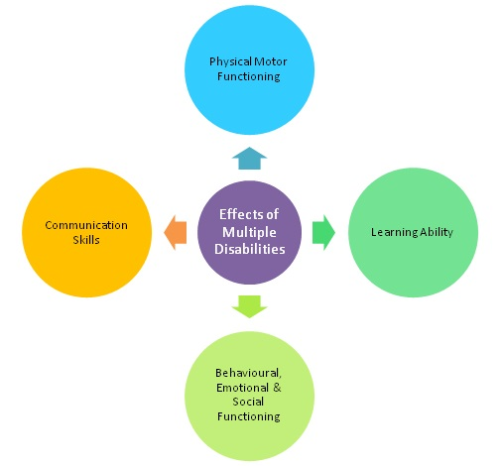

*Figure 5:* Impact of multiple disabilities.